**College of Applied and Collaborative Studies**

(Formerly named New College)

**How to Schedule a Drop-In Advising Appointment**

1. Go to NAVIGATE.UNT.EDU. Follow the instructions to download the mobile app or visit the desktop version here: https://unt.navigate.eab.com/
2. Login with your UNT EUID and password, if prompted.
3. Select the APPOINTMENTS icon on the mobile app or the APPOINTMENTS option on the left-hand menu from the desktop version.

|  |  |
| --- | --- |
| **Mobile App** | **Desktop Version** |
|  |  |

1. SELECT THE SCHEDULE AN APPOINTMENT BUTTON



1. Select VIEW DROP-IN TIMES
   1. **MOBILE APP:** Scroll down to find it under OTHER OPTIONS
   2. **DESKTOP:** Will appear on the top right of the page under OTHER OPTIONS

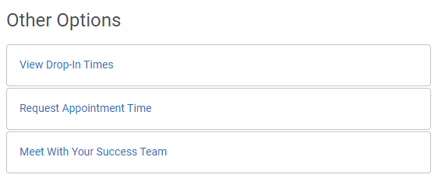

1. Select ACADEMIC ADVISING for the appointment type and DROP-IN WITH AN ADVISOR for the service and then select FIND AVAILABLE TIME.

1. Select the option of College of Applied & Collaborative Studies Advising

1. Review the information to determine when the college advisors are hosting drop-ins. If drop-ins are active, you can use the CHECK-IN button to add yourself to the queue.